**HOW TO MAKE MOI MOI (BEANS PUDDING)**

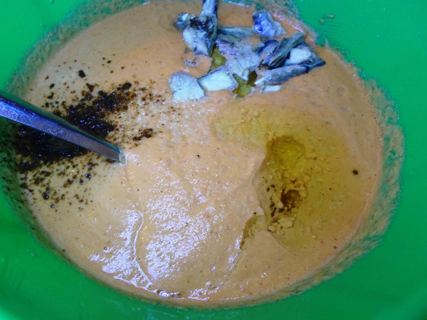

Here are the Ingredients I used while making the plate of moi moi below, you are free to increase the quantity of ingredients or reduce them depending on the number of persons you are looking to serve. These ingredients would serve six persons.

**INGREDIENTS**

* 1 kg of Mackerel
* 7 Cooked Eggs (optional)
* Half cup of vegetable oil
* Maggi (seasoning, 2 to 3 cubes)
* Salt to taste.
* 1 cup of sliced onions
* Tatashe or shobo (about 5 to 10, it add the reddish color)
* Crayfish (1 cup)
* 3 cups of beans

**HOW TO MAKE MOI MOI**

What you find above are the images of some of the ingredients for making beans pudding as well of that of ground moin moin on the left and right respectively.

There is a special kind of beans (moi moi beans) used for making beans pudding in Nigerian but you can substitute with any other type of beans if you live outside Nigeria.

You can use the cooked eggs, corned beef, fish of any kind or a blend of both to make moi moi. Here I used fish and eggs, I simply parboiled the fish, removed the center bones and split into smaller pieces

**HOW TO MAKE MOI MOI (BEANS PUDDING)**

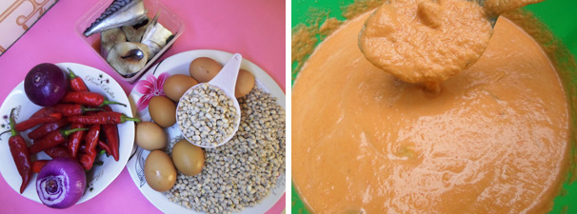

* Please add the beans into a bowl, sprinkle a handful of water and start squeezing with your hands. This is the easiest way to wash beans; you would be through in 20 minutes. You can add a little more water but don’t allow it to soak; continue squeezing until it starts shading off the outer coat, you’d probably be doing this for about 3 minutes.
* When it seems like a good amount of the beans have shaded off their outer-coat, add enough water to fill the bowl, the outer coat would rise to the top, sieve and continue squeezing. At some point there would be just very few that have not shaded off their outer coat, work on them and keep washing.
* Wash the beans to remove the outer coat, keep squeezing, washing and sieving till you are left with the white beans then you can prepare for the grinding part.
* There are people in Nigeria that render the service of grinding food stuff like moi moi or tomatoes in large quantity
* Split the red tatashe or shobo into two halves to remove the seeds at the center, this practice is necessary because the seeds add a bitter unpleasant taste to moi moi. Wash and also pluck off the green stem at the top.
* What I do at this point is to add all of them (beans, onions, crayfish and tatashe or shobo) in a small clean bucket and take to the commercial grinding mill.
* You can use a smart blender for this if you have one, I used my semi-smart blender and it didn’t do a perfect job but it was good enough.
* Parboil the fresh /frozen fish, pick out from the water then pieces the fish with your fingers, not really squashing (leave in bits) Add this to the mixture. At this point you can also add corned beef in place of the fish or a blend of both.
* Below is the image of my favorite moi moi (beans pudding)
* Moi moi (beans pudding)
* While still in the bowl, add the oil just pour into the ground beans – about half cup, add 2 cubes of maggi seasoning, the fish water (fish stock) (which must not be over half cup or so) salt to taste. Taste the entire mixture.
* ground moi moi
* The egg can be dropped on top after the moi-moi has been distributed in cooking plates, if you want to use eggs.
* Distribute in as many plates as possible, some people use moi-moi wrappers for this purpose. After the distribution you can drop into the cooking pot.
* If you are cooking with plates, you can drop the plates on top of each other but you must drop tiny logs of woods or pieces of clothes at the bottom of the pot to avoid burning (some people use the stem of the moi-moi-wrapper), you don’t really need them if you are careful.
* making moi moi
* Drop the plates in the pot and add water simultaneously making sure it doesn’t top the first plate. Then cover tightly and cook for about 40 to 60 minutes adding water at interval to avoid burning or too much water that would run into the plates.
* This part is monitored closely because if you allow the pot to dry the plates would start melting especially if you are using plastic plates. Note that plastic plates can cook for hours without melting or getting burned, the exception is when the pot is completely dried.
* You can bring out one of the plates after cooking for 40 minutes to check if it is done, check again after ten minutes, once it is done, allow to cool off for 30-60 minutes; then serve with pap (akamu), rice or custard.